GitHub guide: how IWP uses it

Created 5/28/2015 by Jacqui Young

Includes:

1. Signing up for GitHub
2. Downloading GitHub and saving a new document
3. Opening a current document in GitHub
4. How to make a folder/ branch in GitHub
5. Transferring who is in charge of a repository.
6. Signing up for GitHub
7. Go to GitHub.com and sign up, I reccommed making your username the same username that you have through Messiah College (ie. jy1189).
8. You should get a confirmation email.
9. After you are all signed up, click on the search bar in the top left hand corner and type in “**intelligent water”**
10. **Downloading GitHub and saving a new document**
11. Download github on <https://github.com/> (you may need to get Paul Myers or IT to give you permission to download it onto a school computer)

(IT’s number: 717.796.1800 x3333)

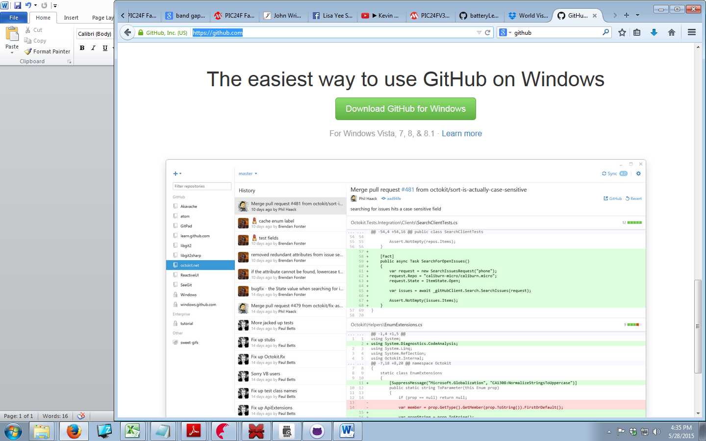

1. Open up the GitHub **folder** which should now be on your desktop

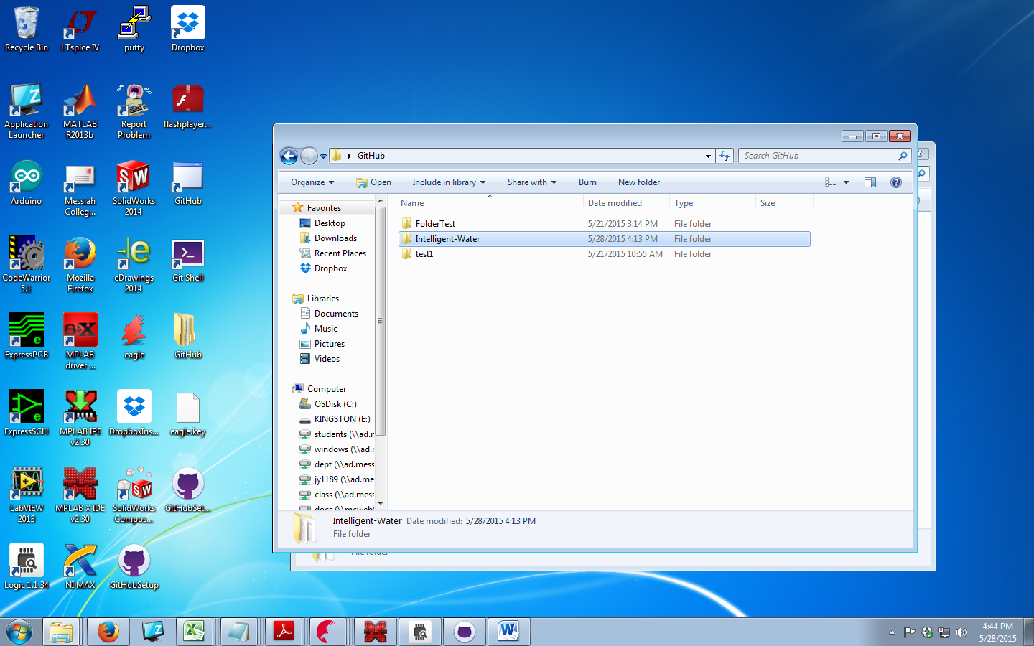

1. Select where you want to save your new file

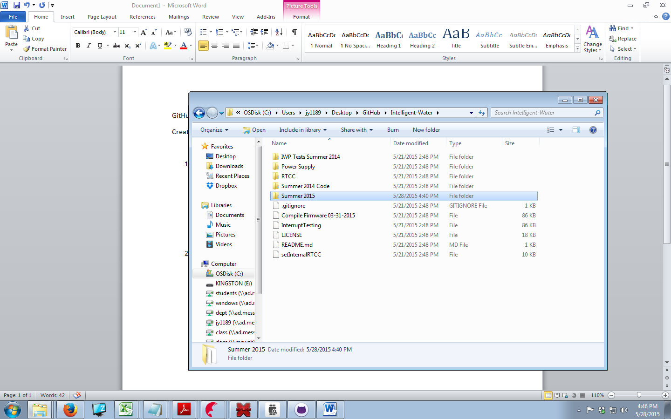

1. Now open up GitHub on your desktop, and Sync the file.

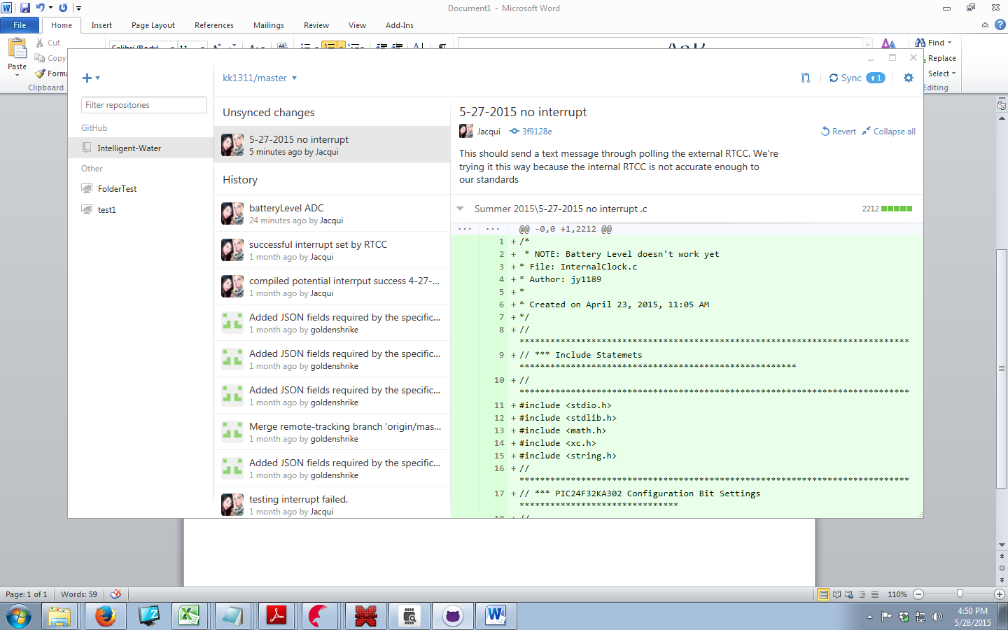

1. **Opening a current document in GitHub**
2. Open up github.com and log in.
3. Click on our project

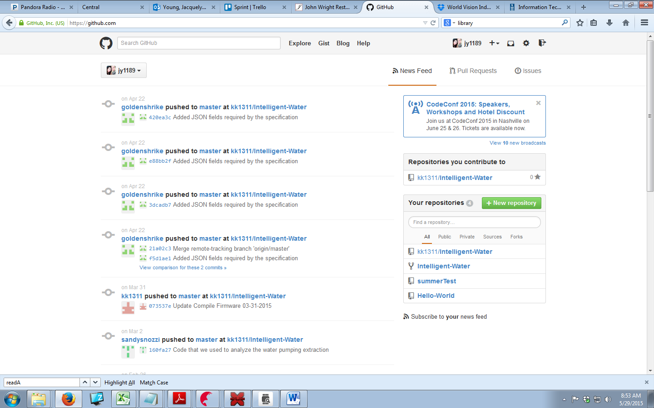

1. Click on the branch (folder) you want

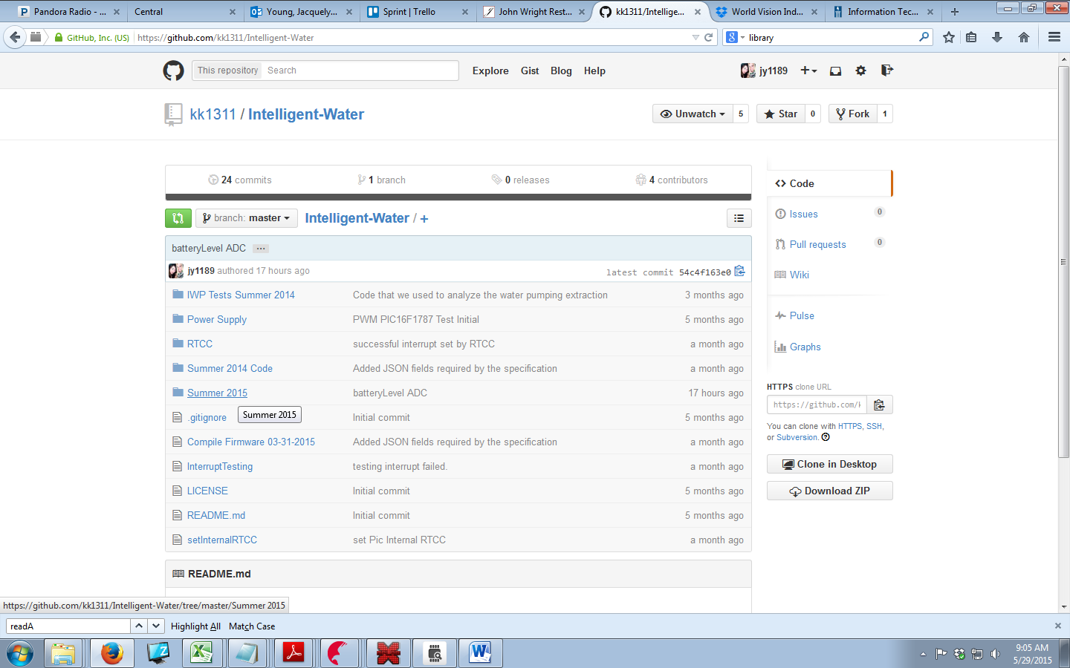

1. Add a “mini title” for changes made with a detailed description to go underneath to help those in the future. After you have completed this commit the file to master.

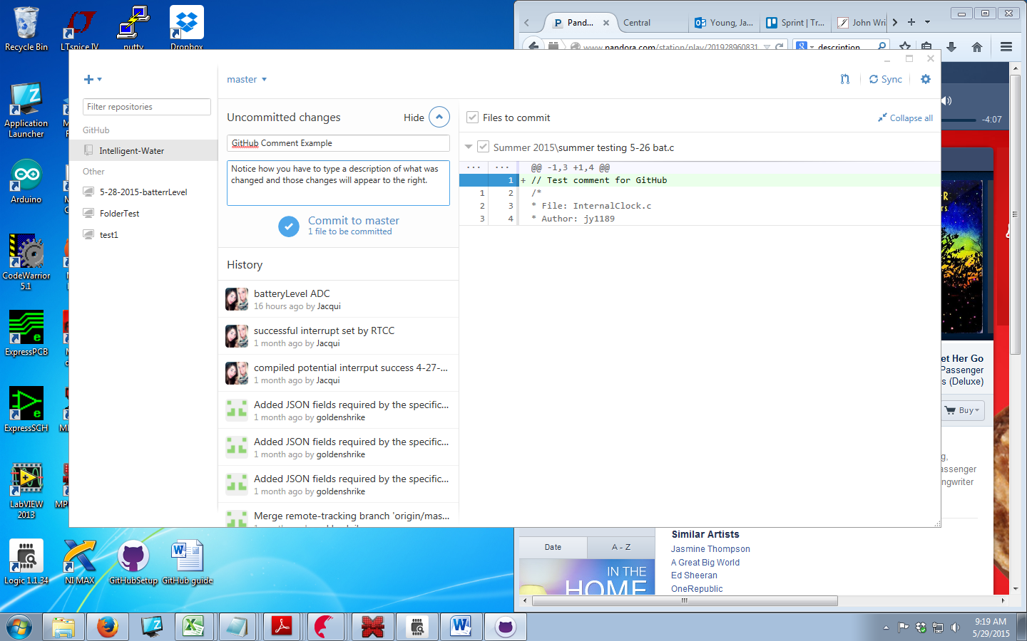

1. Remember to Sync the file!

How to make a folder/ branch in GitHub

1. After you downloaded GitHub you should have also downloaded a GitHub folder. Open it. Then open up the Project you want to make a folder (aka branch) in. Right Click > new > Folder

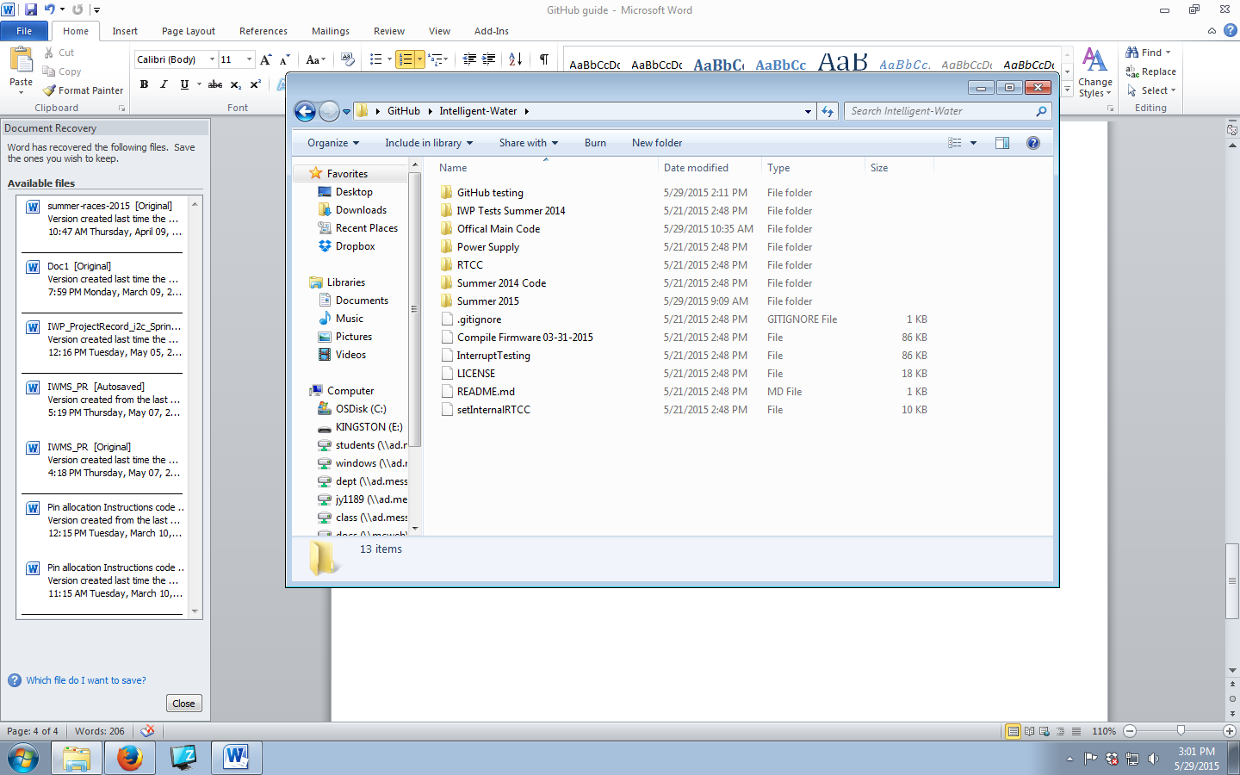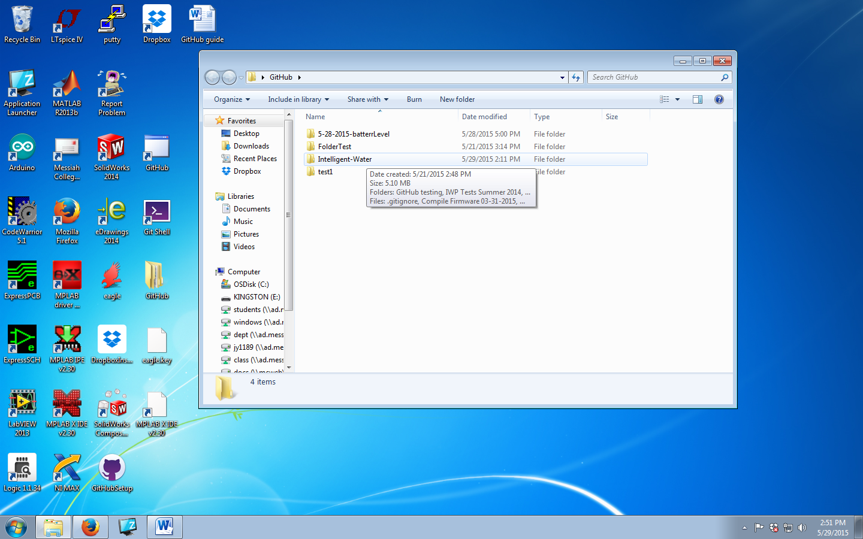

2) For this folder/branch to appear online, there must be a document inside the folder.

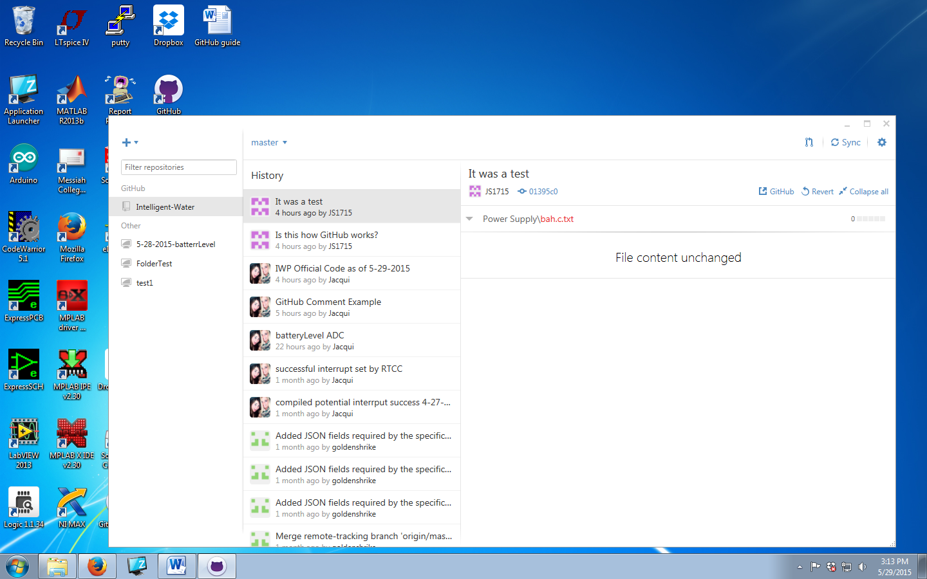

Transferring who is in charge of a repository

1. The current person in ownership of the repository needs to initiate.
2. The owner of the repository needs to click on the repository you want to move.



1. Then click on settings.

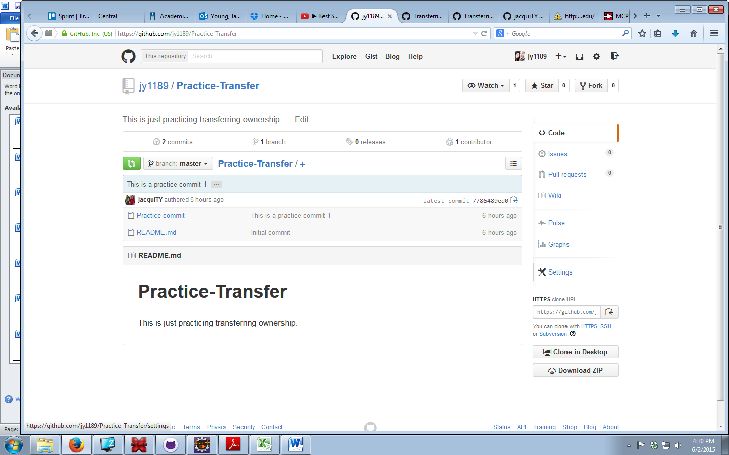

1. Scroll down to the “Danger Zone,” and click Transfer.

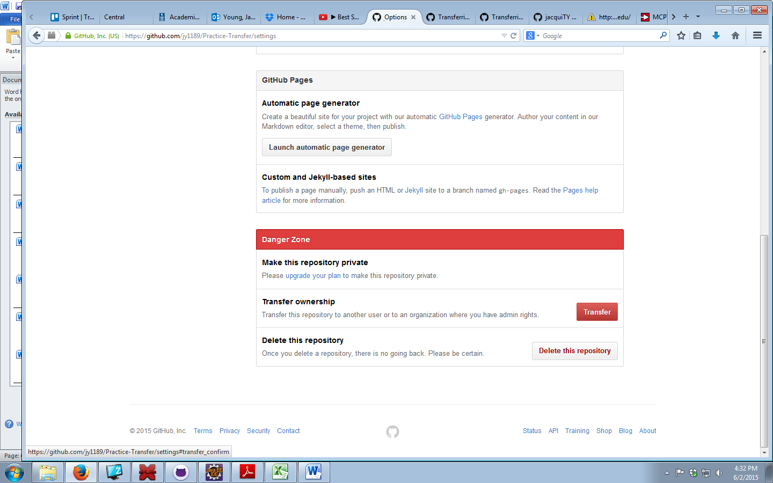

1. Next you will need to know the **name of the repository** you want to transfer as well as the **username** of the person you want to transfer it to.

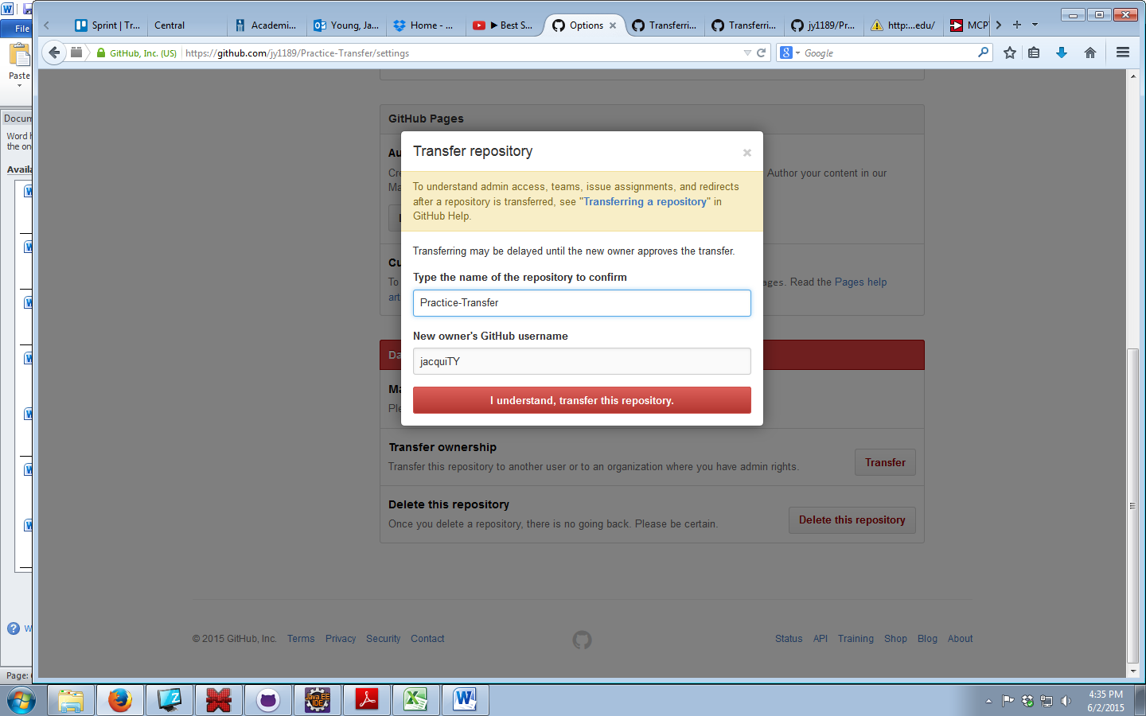

1. You will then have to confirm your password.
2. An E-mail has now been generated and sent to the new owner (if they accept). You are still in charge of this repository until they accept it. They have about a day to accept it, if they don’t accept nothing has changed.
3. The future owner needs to log on to their email and click the link that they accept the position as the new owner of the repository.

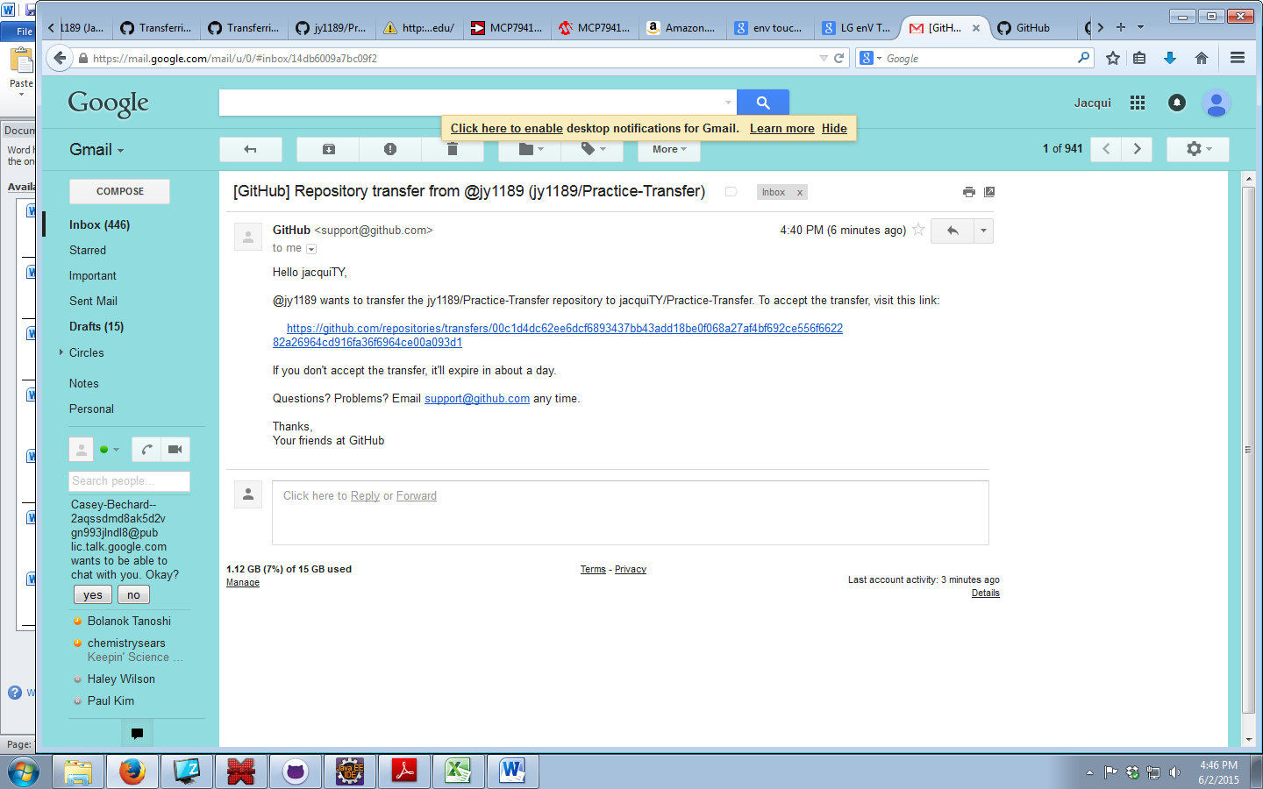

1. The new owner will then be taken to GitHub where they need to log on to make the transfer permanent. Once you do that you will see a message displayed letting you know you successfully accepted the transfer.

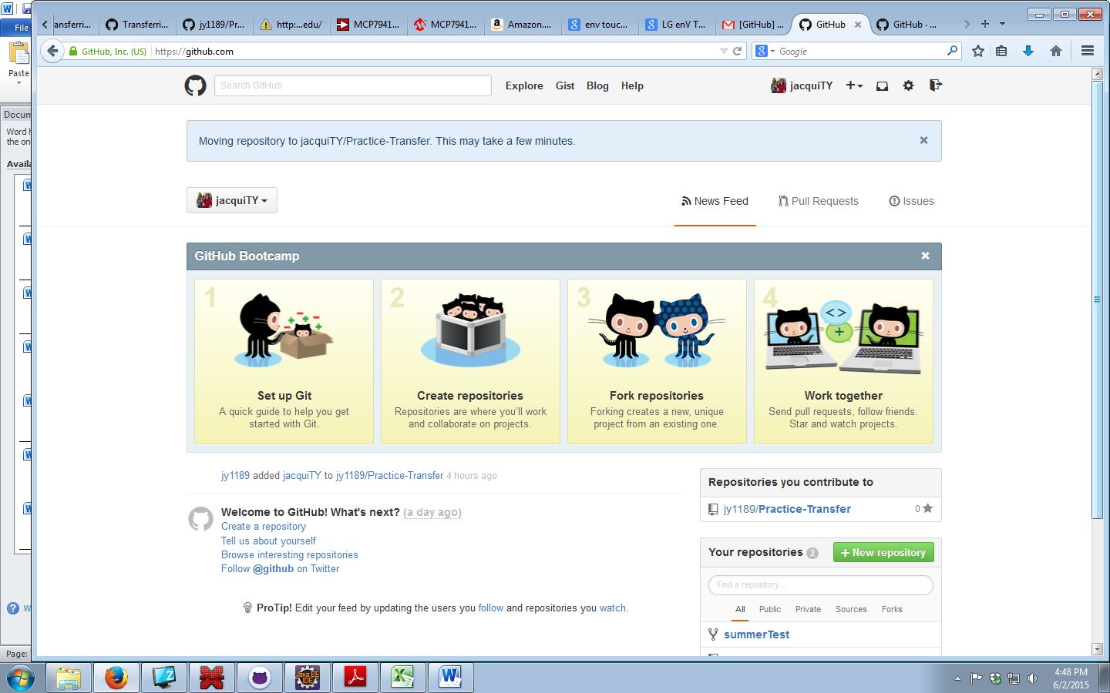

1. The previous owner should receive an e-mail when the new owner accepts ownership.

